AVA An Automated Voice Activated Advisement System

(Code and Test images)

By: The Software Gurus

Team Members:

Omar Obidat

Jesse Parron

Allen Asencio

Dan Ferdetta

Sumit Mistry

Software Engineering 515

Fall 2022

Professor Johnson

November 21, 2022

**Introduction**:

This document shows some images of the modules being implemented and tested individually. So far, implementation is going well and we are getting some bugs with the language recognition, but that will be sorted out by the next deliverable. We noticed when testing that sometimes based on internet strength the language recognition does not process speech in a quick manner. Due to this, when testing and screenshotting results the team could not include the catalog output. Advising is still in the process of being implemented and will be implemented and functioning by the next deliverable. The team is also working on making the front end more pleasing for the overall user experience. Other functions that will be implemented by the next deliverable is the admin portion of the system.

1. The sign in module that will be connected to the schools database:(below)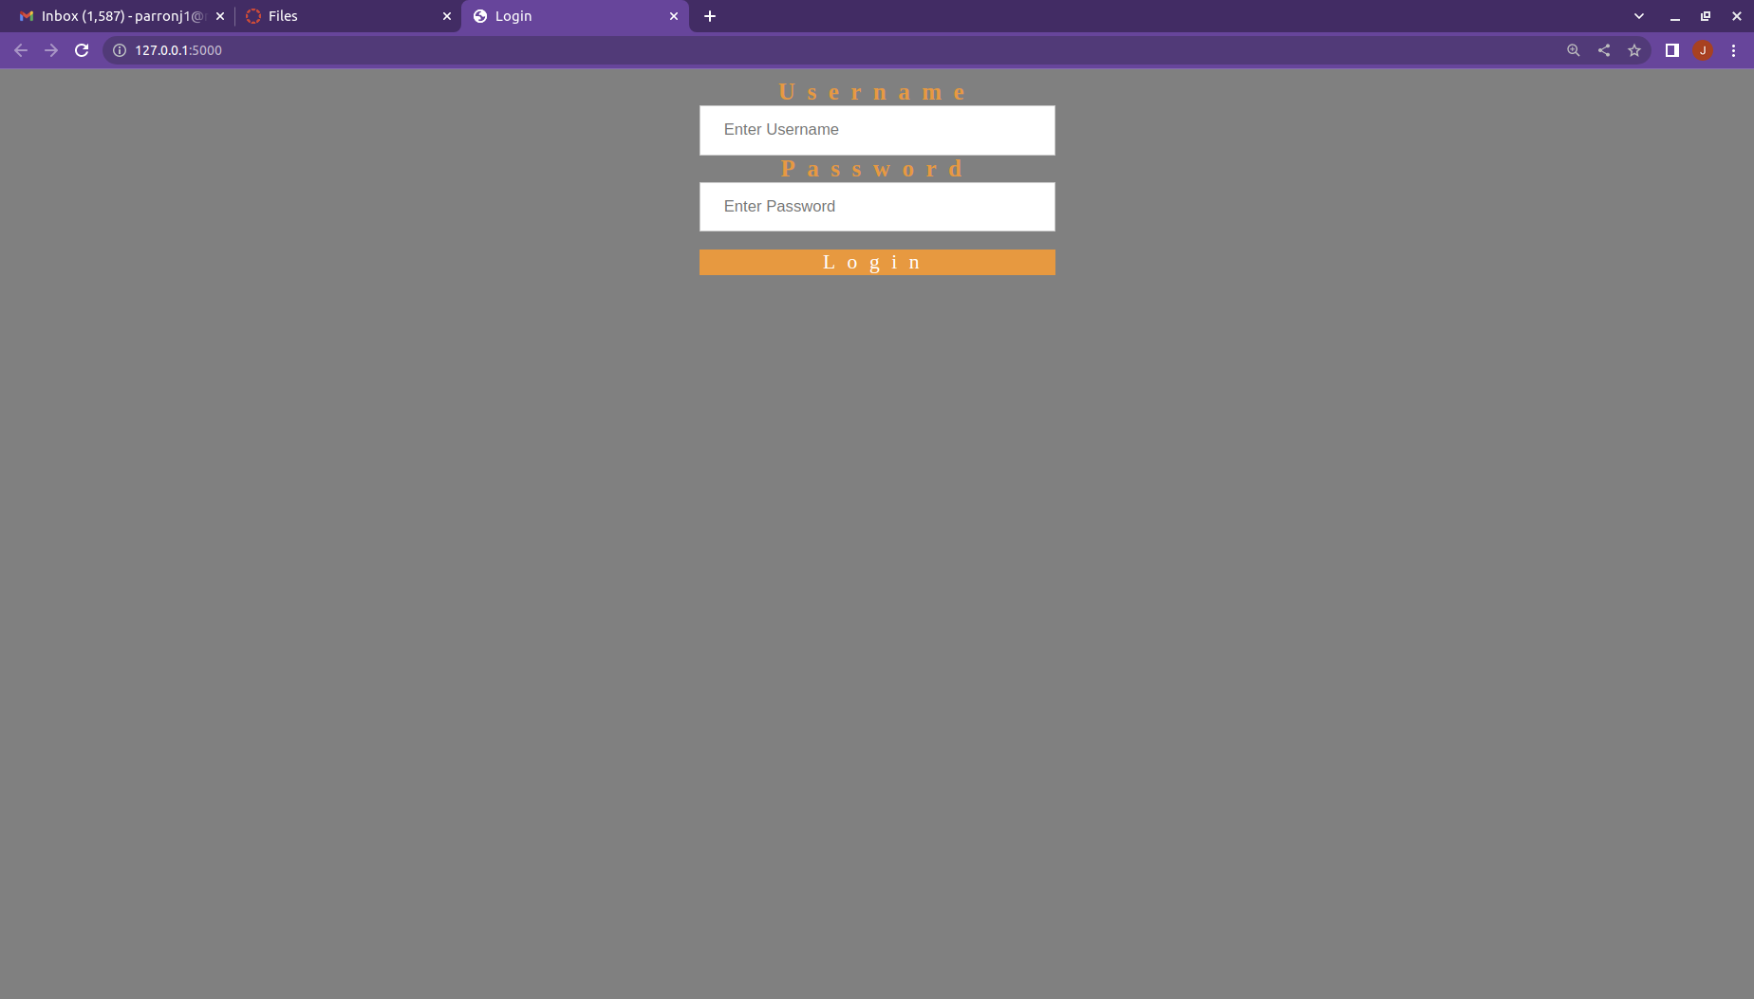
2. The test profile used to login (below)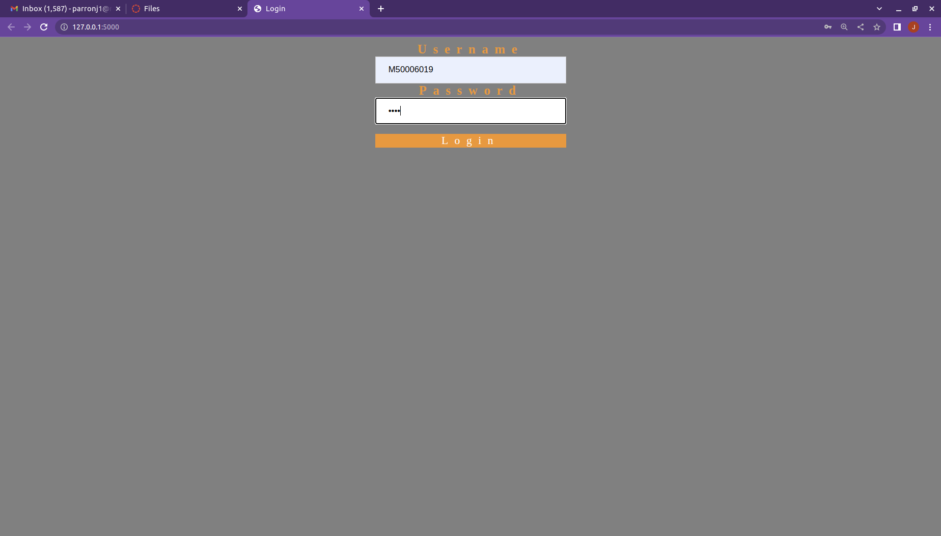
3. The home screen that connects with each module (below)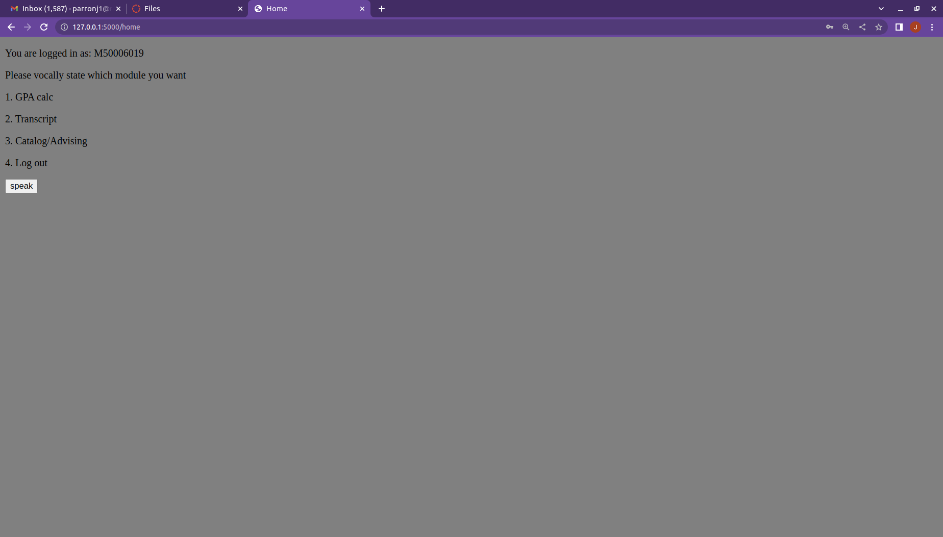
4. The GPA calculator module (below)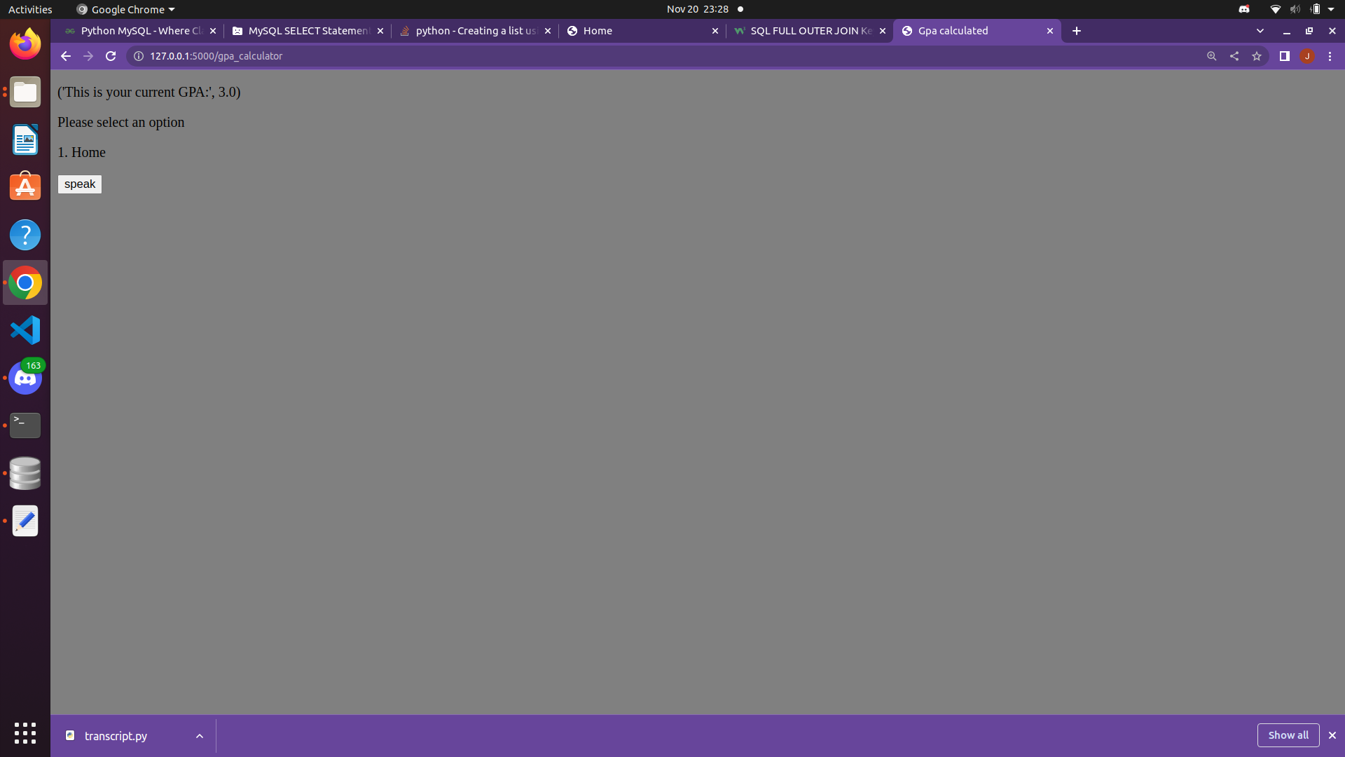
5. The module for the students transcript (below)

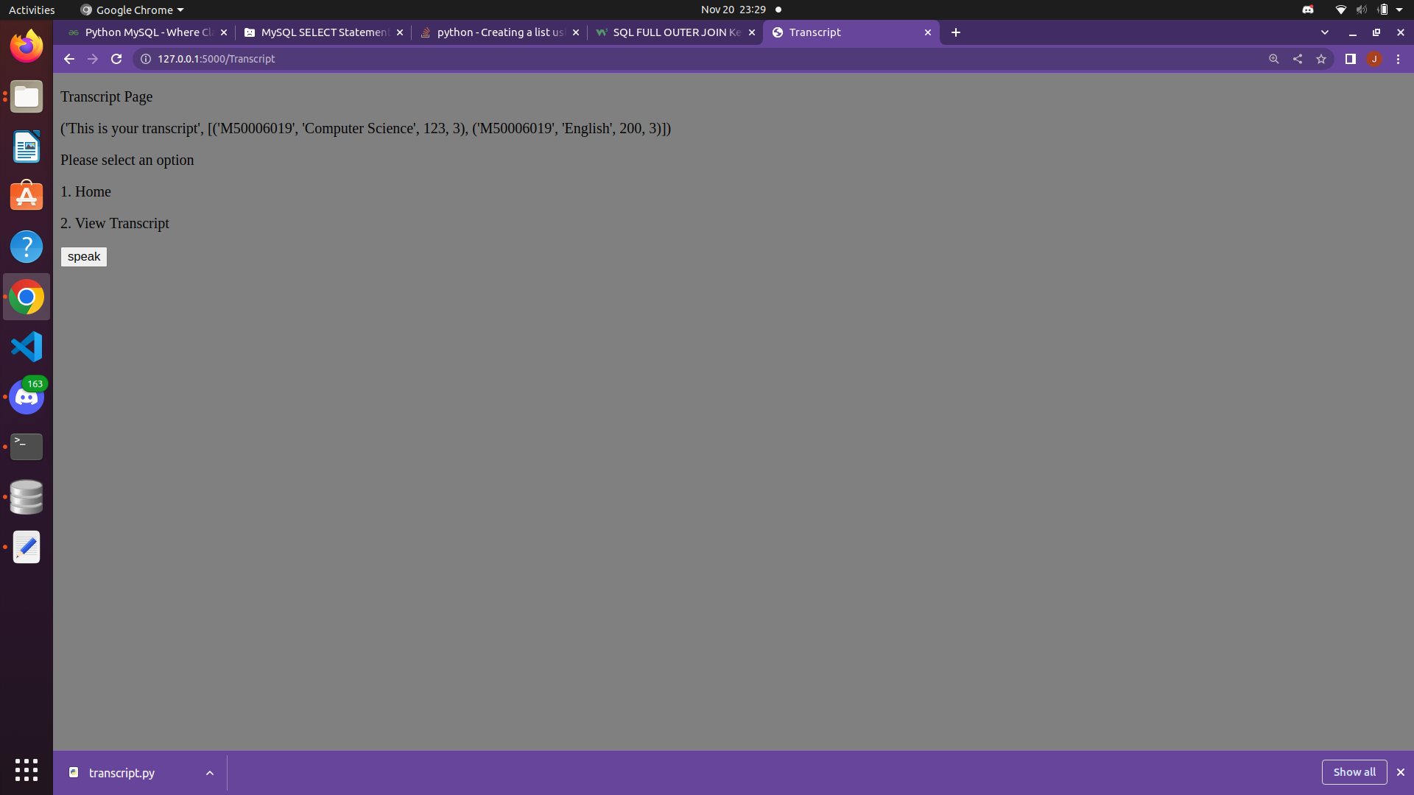

1. The table that has the student profile that will be connected to the login page(below):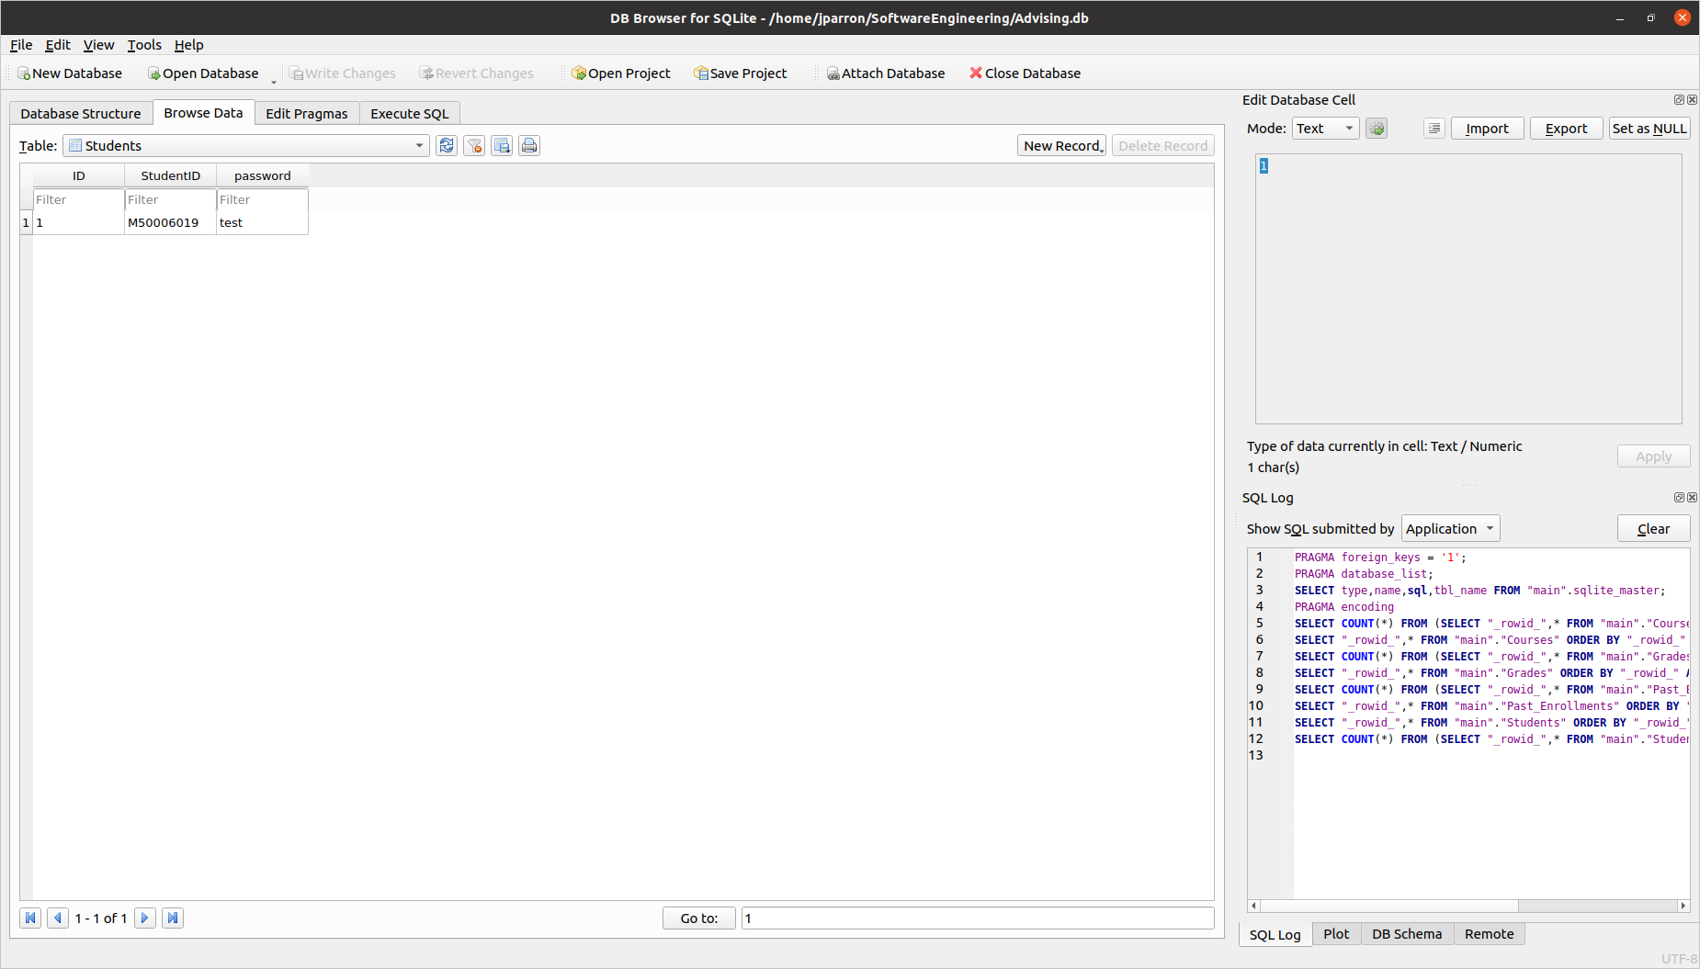
2. The table that will connect each student to the classes that they have taken(below)

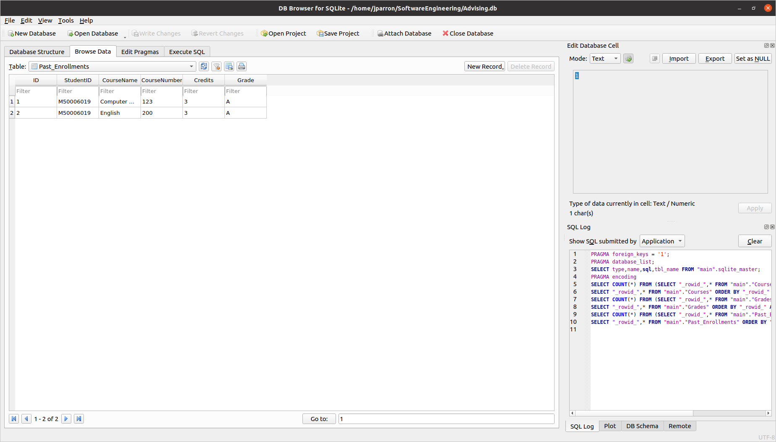

6.This table will show the grades of each student for GPA calculation (below):

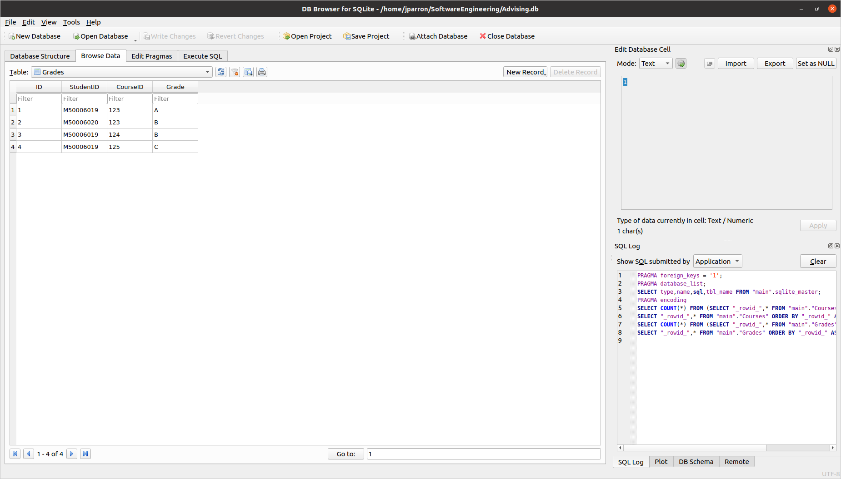

7. This table shows all available courses and the professors teaching them (below):

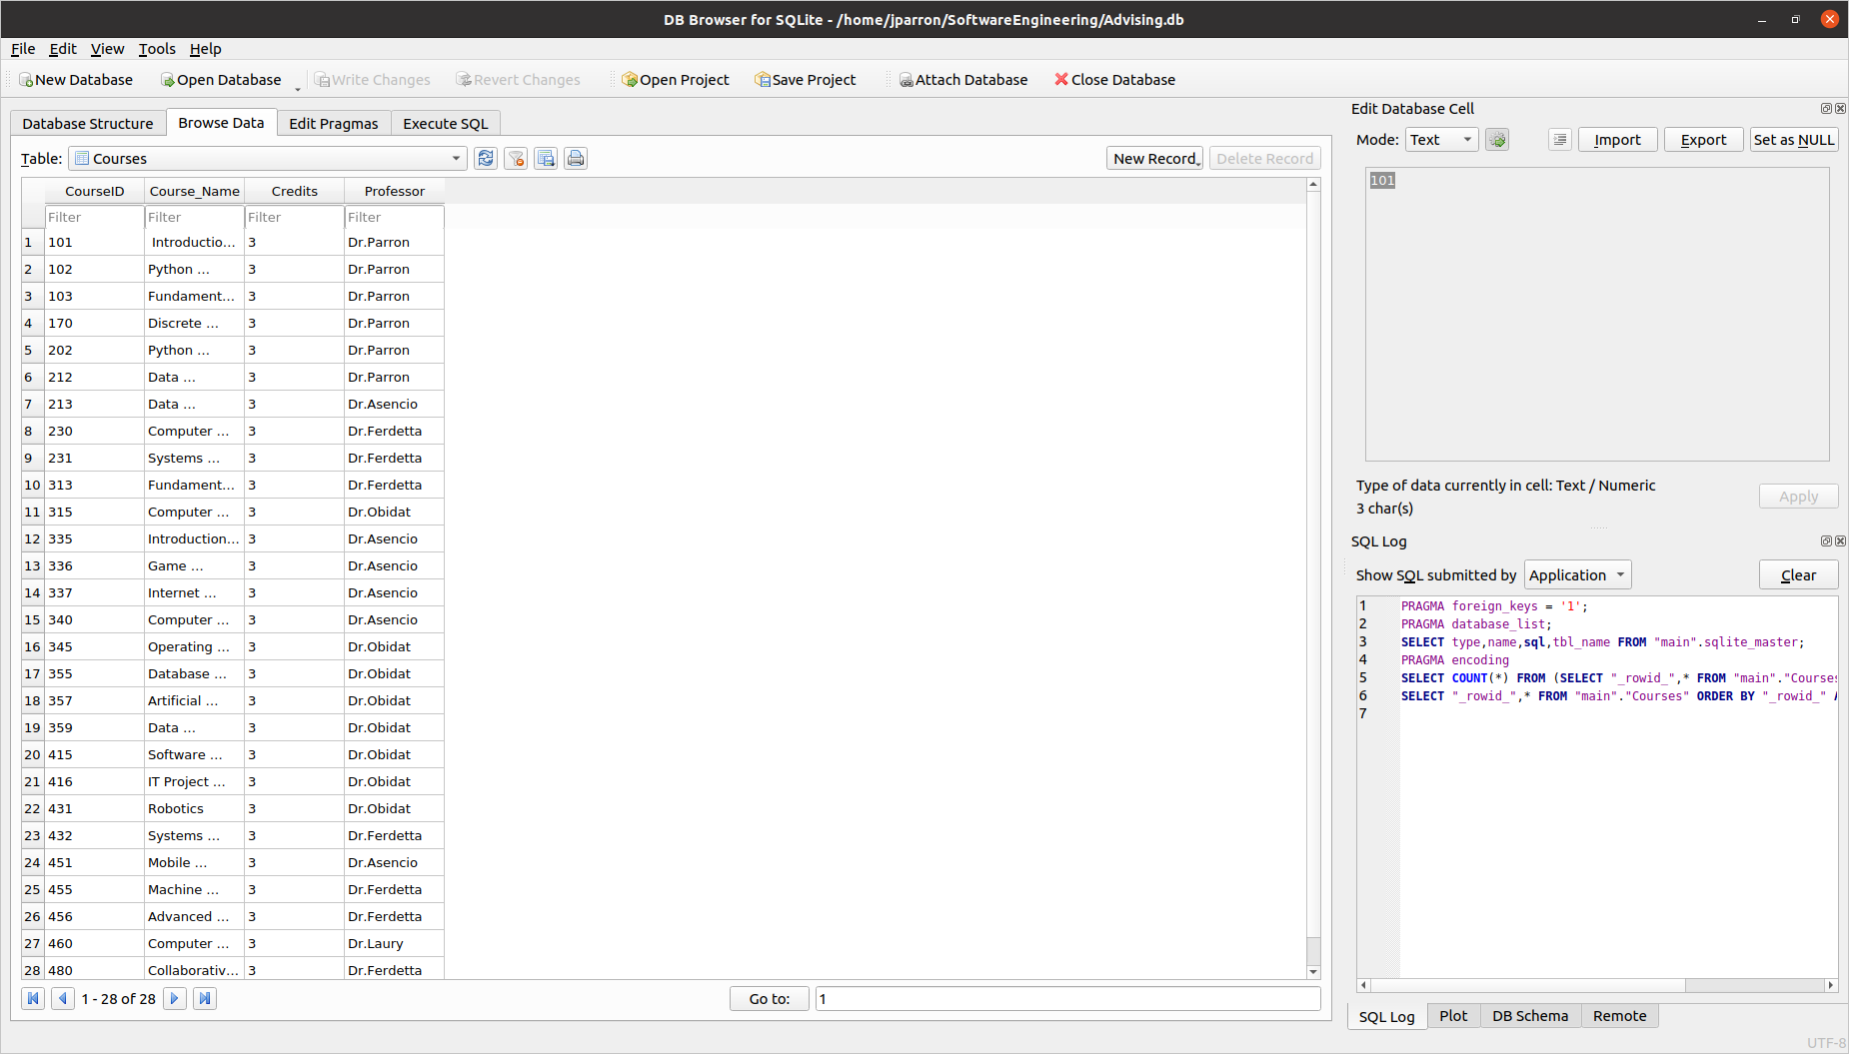

1. Main Code:

Our main code that will create a session, connect to the server, and speech recognition.

from flask import Flask, render_template, request, url_for, flash, redirect, session

import sqlite3 as sql

import speech_recognition as sr

app = Flask(__name__, template_folder = 'pages')

app.config['SESSION_TYPE'] = 'filesystem'

app.config["SESSION_PERMANENT"] = False

loginVer = 0

def home():

# get audio from the microphone

r = sr.Recognizer()

with sr.Microphone() as source:

print("Speak:")

audio1 = r.listen(source)

audio = r.recognize_google(audio1)

return audio

@app.route('/')

def login():

return render_template('login.html')

@app.route('/home', methods = ['POST'])

def loginVerification():

global loginVer

if request.method == 'POST':

username = request.form['username']

password = request.form['password']

with sql.connect("Advising.db") as con:

cur = con.cursor()

cur.execute('SELECT * FROM Students WHERE StudentID = ? AND password = ?', (username, password,))

con.commit

# Fetch one record and return result

Student = cur.fetchone()

if Student == None:

return render_template('login.html')

if Student[1] == username:

print(Student)

session['username'] = username

question = 'Please vocally state which module you want'

return render_template('home.html', question=question)

else:

return render_template('login.html')

@app.route('/speak', methods = ['POST'])

def speakHomeModule():

if request.method == 'POST':

value = request.form['button']

if value == '1':

audio = home()

print("you said", audio)

if "transcript" in audio:

return render_template('transcript.html')

elif "GPA" in audio:

return render_template('GPA.html')

elif "catalog" in audio:

return render_template('catalog.html')

elif "logoff" in audio:

return render_template('logoff.html')

else:

question = 'you didnt say a choice, please make sure to say a choice'

return render_template('home.html', question=question)

@app.route('/gpa_calculator', methods = ['POST'])

def GPA_calculator():

if request.method == 'POST':

value = request.form['button']

if value == '1':

audio = home()

print("you said", audio)

if "calculate" in audio:

points = 0

grade_c = {"A":4,"A-":3.67

,"B+":3.33,"B":3.0

,"B-":2.67, "C+":2.33

,"C":2.0,"C-":1.67

,"D+":1.33,"D":1.0

,"F":0}

studentID = session['username']

with sql.connect("Advising.db") as con:

cur = con.cursor()

cur.execute('SELECT StudentID, Grade FROM Grades WHERE StudentID = ?', (studentID,))

con.commit

Student = cur.fetchall()

length = len(Student)

grades = []

for x in range(length):

grades.append(Student[x][1])

print(grades)

for grade in grades:

points += grade_c[grade]

gpa = points / len(grades)

print(gpa)

question = ('This is your current GPA:', gpa)

q1 = "Home"

return render_template('GPA2.html', question=question, q1=q1)

elif "what if" in audio:

q1 = "Home"

question = "You chose what-if"

return render_template('GPA2.html', question=question, q1=q1)

@app.route('/home_or_whatif', methods = ['POST'])

def home_or_whatif():

if request.method == 'POST':

value = request.form['button']

if value == '1':

audio = home()

print("you said", audio)

if "home" in audio:

return render_template('home.html')

elif "what if" in audio:

question = "You chose what-if"

q1 = "Home"

return render_template('GPA2.html', question=question, q1=q1)

else:

question = "Sorry, did not understand what you said"

q1 = "Home"

return render_template('GPA2.html', question=question, q1=q1)

@app.route('/Transcript', methods = ['POST'])

def transcript():

if request.method == 'POST':

value = request.form['button']

if value == '1':

audio = home()

print("you said", audio)

if "home" in audio:

return render_template('home.html')

elif "transcript" in audio:

studentID = session['username']

with sql.connect("Advising.db") as con:

cur = con.cursor()

cur.execute('SELECT StudentID, CourseName, CourseNumber, Credits FROM Past_Enrollments WHERE StudentID = ?', (studentID,))

con.commit

Student = cur.fetchall()

Student_Transcript = "This is your transcript",Student

return render_template("transcript.html", Student_Transcript=Student_Transcript)

else:

question = "Sorry, did not understand what you said"

return render_template("transcript.html", question=question)

@app.route('/Catalog', methods = ['POST'])

def catalog():

if request.method == 'POST':

value = request.form['button']

if value == '1':

audio = home()

print("you said", audio)

if "home" in audio:

return render_template('home.html')

elif "catalog" in audio:

with sql.connect("Advising.db") as con:

cur = con.cursor()

cur.execute('SELECT * FROM Courses')

con.commit

courses = cur.fetchall()

Statement = ("Here are all the courses")

course_catalog = courses

return render_template("catalog.html", Statement=Statement, course_catalog=course_catalog)

else:

Statement = "Sorry didnt understand what you said"

return render_template("catalog.html", Statement=Statement)

#@app.route('/Advising', methods=['POST'])

#def advising():

#to be implemented next

if __name__ == '__main__':

app.secret_key = 'super secret key'

app.run(debug=True)

2. Catalog code:

This is the html code that will be displayed for the user code:

<!DOCTYPE html>

<html>

<head>

<head>

<meta charset = "utf-8">

<title>Catalog</title>

</head>

</head>

<body style="background-color: grey;">

<p> Catalog Page </p>

<p>{{Statement}}</p>

{% for course in course_catalog %}

<p>{{course}}</p>

{% endfor %}

<p>Please select an option</p>

<p>1. Home</p>

<p>2. View Catalog</p>

<p>3. Advise</p>

<form action="Catalog" method="post">

<button name="button" value="1">speak</button>

</form>

</body>

</html>

3. GPA codes:

It has 2 sub-modules one for possible GPA and one for current GPA:

<!DOCTYPE html>

<html>

<head>

<head>

<meta charset = "utf-8">

<title>Home</title>

</head>

</head>

<body style="background-color: grey;">

<p>{{question}}</p>

<p> GPA Page </p>

<p>Please select an option</p>

<p>1. Calculate current GPA</p>

<p>2. What-if GPA</p>

<form action="gpa_calculator" method="post">

<button name="button" value="1">speak</button>

</form>

</body>

</html>

<!DOCTYPE html>

<html>

<head>

<head>

<meta charset = "utf-8">

<title>Gpa calculated</title>

</head>

</head>

<body style="background-color: grey;">

<p>{{question}}</p>

<p>Please select an option</p>

<p>1. {{q1}}</p>

<form action="home_or_whatif" method="post">

<button name="button" value="1">speak</button>

</form>

</body>

</html>

4. Home interface code:

The interface for our home screen done in html

<!DOCTYPE html>

<html>

<head>

<head>

<meta charset = "utf-8">

<title>Home</title>

</head>

</head>

<body style="background-color: grey;">

<p>You are logged in as: {{session.username}}</p>

<p>{{question}}</p>

<p>1. GPA calc</p>

<p>2. Transcript</p>

<p>3. Catalog/Advising </p>

<p>4. Log out</p>

</body>

<form action="speak" method="post">

<button name="button" value="1">speak</button>

</form>

</html>

5. Login code:

Our login page code

<!DOCTYPE html>

<html>

<head>

<title>Login</title>

<style>

.imgcontainer {

text-align: center;

padding-top: 0px;

padding-bottom: -100px;

}

img {

margin-top: 15px;

width: 400px;

height: auto;

}

label {

text-align: center;

color: rgba(254, 149, 28, 255);

font-family: "Shenttpuro";

font-size: 15pt;

letter-spacing: 10px;

}

.container {

text-align: center;

}

input[type=text],

input[type=password] {

width: 300px;

padding: 12px 20px;

margin: 0px 10px;

display: inline-block;

border: 1px solid #ccc;

box-sizing: border-box;

}

.button1 {

background-color: rgba(254, 149, 28, 255);

color: white;

border: none;

cursor: pointer;

width: 300px;

font-size: 13pt;

margin-top: 15px;

margin-bottom: 5px;

font-family: "Shenttpuro";

letter-spacing: 10px;

}

.button2 {

background-color: rgba(254, 149, 28, 255);

color: white;

border: none;

cursor: pointer;

width: 300px;

font-size: 13pt;

margin-top: 10px;

margin-bottom: 5px;

font-family: "Shenttpuro";

letter-spacing: 10px;

}

.a2 {

text-decoration:none;

color: white;

}

.a1 {

text-decoration:none;

color: rgba(254, 149, 28, 255);

}

.p1 {

text-align: center;

font-family: "Shenttpuro";

font-size: 15pt;

letter-spacing: 10px;

color: rgba(254, 149, 28, 255);

}

</style>

</head>

<body style="background-color: grey;">

<form action = "/home" method = "POST">

<div class="container">

<label for="username"><b>Username</b></label>

</div>

<div class="container">

<input type="text" placeholder="Enter Username" name="username" required>

</div>

<div class="container">

<label for="password" style="font-family: Shenttpuro; text-align: center" ;><b>Password</b></label>

</div>

<div class="container">

<input type="password" placeholder="Enter Password" name="password" required>

</div>

<div class="container">

<button class="button1" type="submit" name="Login">Login</button>

</div>

</form>

</body>

</html>

6. Transcript code:

The code written to generate the users transcript

<!DOCTYPE html>

<html>

<head>

<head>

<meta charset = "utf-8">

<title>Transcript</title>

</head>

</head>

<body style="background-color: grey;">

<p>{{question}}</p>

<p> Transcript Page </p>

<p>{{Student_Transcript}}</p>

<p>Please select an option</p>

<p>1. Home</p>

<p>2. View Transcript</p>

<form action="Transcript" method="post">

<button name="button" value="1">speak</button>

</form>

</body>

</html>